Project 9.2 — FIFO design Async.

1. Block Diagram with Port Map
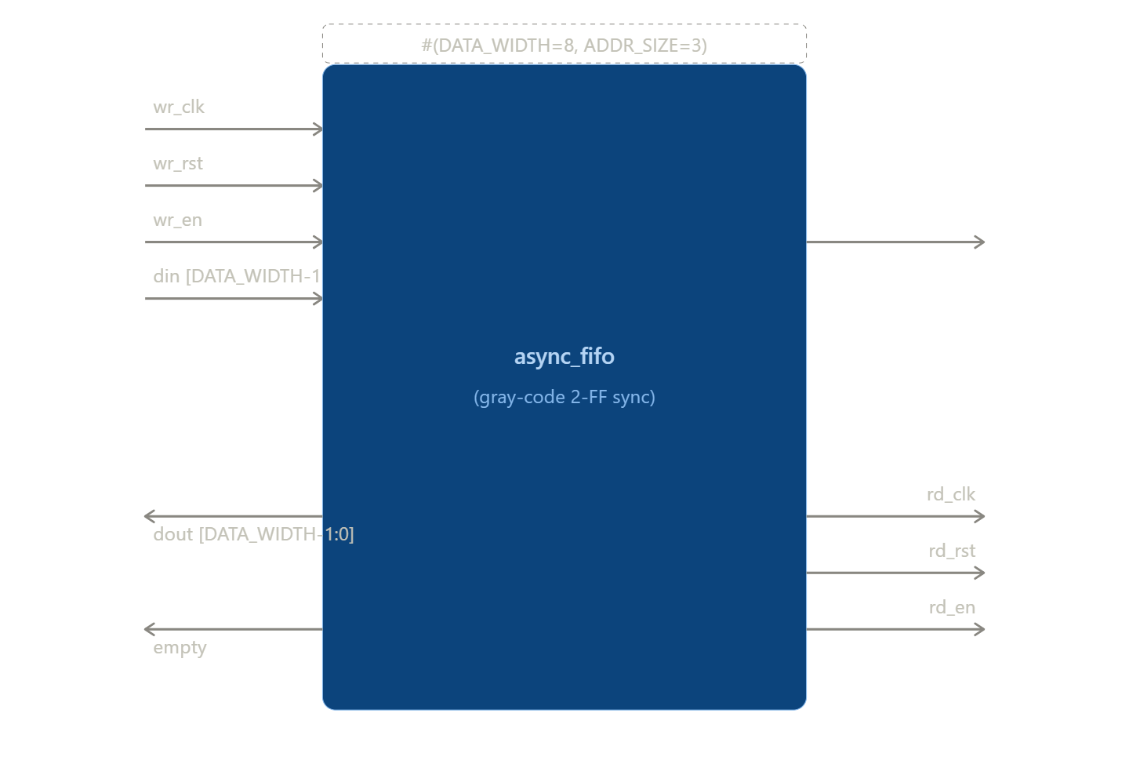
full
Port Map Table
Port Name | Direction | Width | Description
Wr_clk | Input | 1 | Clock to the write module.
Wr_rst | Input | 1 | Reset to the write module.
Wr_en | Input | 1 | Write enable.
Din | Input | [data_width-1:0] | Data input in the fifo.
rd_clk | Input | 1 | Clock to the read module.
rd_rst | Input | 1 | Reset to the read module.
rd_en | Input | 1 | Read enable.
Dout | Output | [data_width-1:0] | Data output from fifo.
empty | Output | 1 | Signal to tell when the fifo is empty.
Full | Output | 1 | Signal to tell when the fifo is full.

2. Block Description
In this design I have used different module blocks for different components of the asynchronous FIFO. These inputs are given to these different blocks then these modules come together to make top level design asynchronous FIFO.

3. Pin Description
Pin Name | Pin Type | Polarity | Functional Description
Wr_clk | Clock | Active High | Clock to the write module.
Wr_rst | Control | Active High | Reset to the write module.
Wr_en | Control | Active High | Write enable.
Din | Data | Active High | Data input in the fifo.
rd_clk | Clock | Active High | Clock to the read module.
rd_rst | Control | Active High | Reset to the read module.
rd_en | Control | Active High | Read enable.
Dout | Data | Active High | Data output from fifo.
empty | Data | Active High | Signal to tell when the fifo is empty.
Full | Data | Active High | Signal to tell when the fifo is full.

4.1 RTL Code for synchronizers

I used two flip – flop to verify correct Clock Domain Crossing (CDC). Two-stage synchronizers were used to safely transfer Gray-coded pointers between clock domains, minimizing metastability. Simulation verified correct data transfer along with proper operation of the full and empty flags.
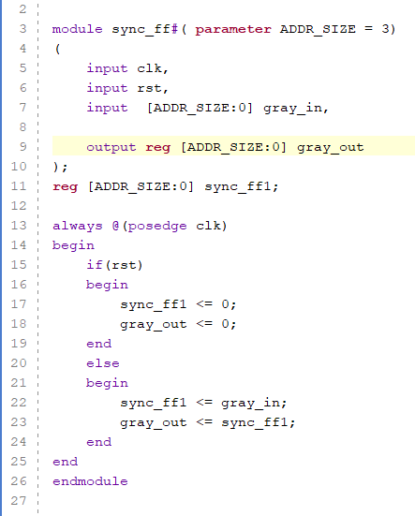

4.2 RTL Code for write control
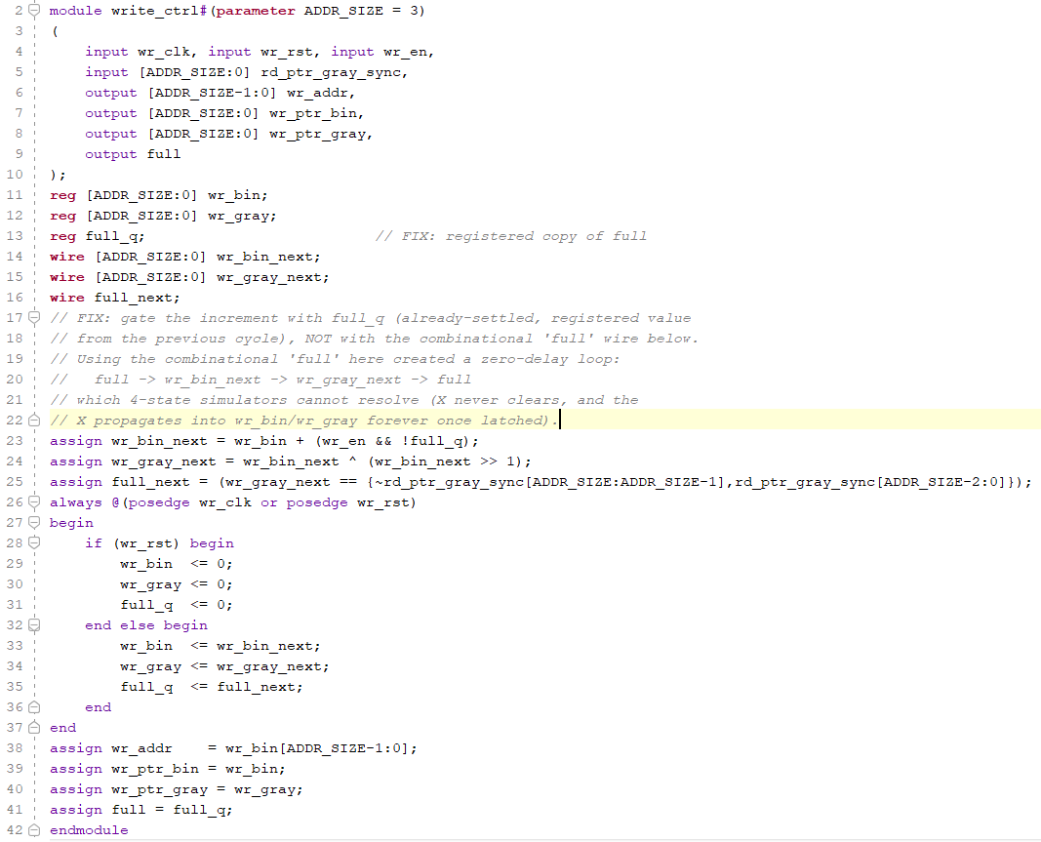

4.3 RTL Code for read control
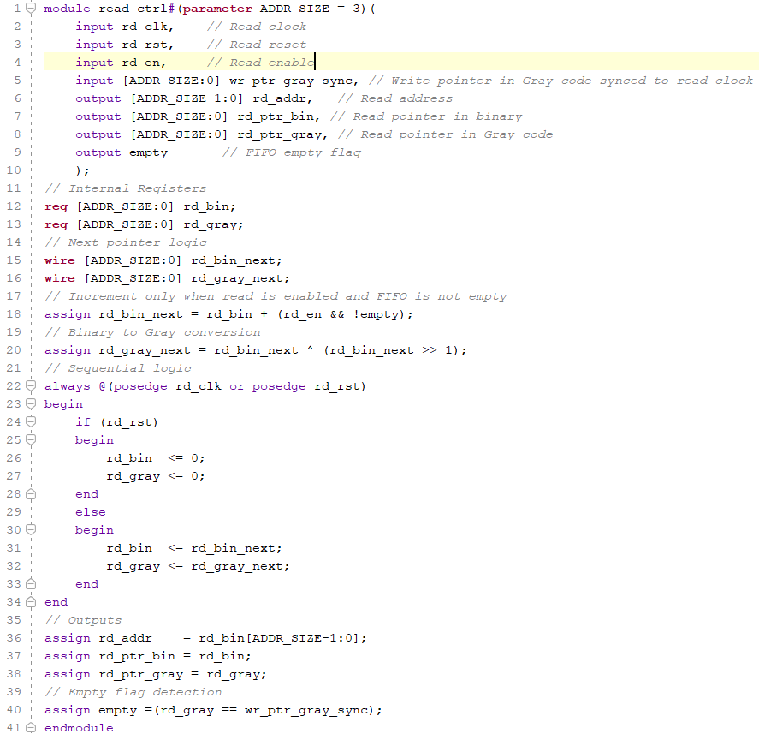

4. RTL Code for FIFO Memory
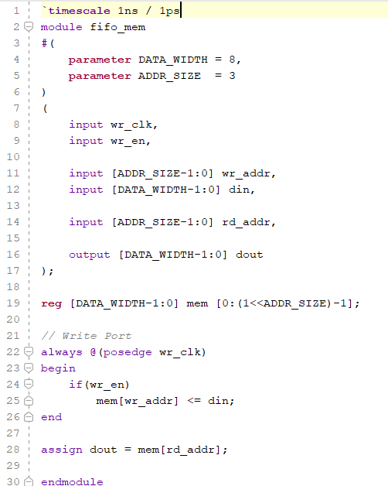

4.5 RTL Code for Top Async. FIFO
`timescale 1ns / 1ps

module async_fifo#(parameter DATA_WIDTH = 8,parameter ADDR_SIZE = 3)
(
// Write Side
input wr_clk,
input wr_rst,
input wr_en,
input [DATA_WIDTH-1:0] din,

// Read Side
input rd_clk,
input rd_rst,
input rd_en,

output [DATA_WIDTH-1:0] dout,

output full,
output empty
);
// Write Pointer
wire [ADDR_SIZE:0] wr_ptr_bin;
wire [ADDR_SIZE:0] wr_ptr_gray;
wire [ADDR_SIZE-1:0] wr_addr;
// Read Pointer
wire [ADDR_SIZE:0] rd_ptr_bin;
wire [ADDR_SIZE:0] rd_ptr_gray;
wire [ADDR_SIZE-1:0] rd_addr;

// Synchronized Gray Pointers
wire [ADDR_SIZE:0] wr_ptr_gray_sync;
wire [ADDR_SIZE:0] rd_ptr_gray_sync;

write_ctrl #(
.ADDR_SIZE(ADDR_SIZE)
)
WR_CTRL
(
.wr_clk(wr_clk),
.wr_rst(wr_rst),
.wr_en(wr_en),

.rd_ptr_gray_sync(rd_ptr_gray_sync),

.wr_addr(wr_addr),
.wr_ptr_bin(wr_ptr_bin),
.wr_ptr_gray(wr_ptr_gray),

.full(full)
);
// Read Controller
read_ctrl #(
.ADDR_SIZE(ADDR_SIZE)
)
RD_CTRL
(
.rd_clk(rd_clk),
.rd_rst(rd_rst),
.rd_en(rd_en),

.wr_ptr_gray_sync(wr_ptr_gray_sync),

.rd_addr(rd_addr),
.rd_ptr_bin(rd_ptr_bin),
.rd_ptr_gray(rd_ptr_gray),

.empty(empty)
);
// FIFO Memory
fifo_mem #(
.DATA_WIDTH(DATA_WIDTH),
.ADDR_SIZE(ADDR_SIZE)
)
MEM
(
.wr_clk(wr_clk),
.wr_en(wr_en && !full),

.wr_addr(wr_addr),
.din(din),

.rd_addr(rd_addr),
.dout(dout)
);
// Write Pointer -> Read Clock Synchronizer
sync_ff #(
.ADDR_SIZE(ADDR_SIZE)
)
WR2RD_SYNC
(
.clk(rd_clk),
.rst(rd_rst),

.gray_in(wr_ptr_gray),
.gray_out(wr_ptr_gray_sync)
);
// Read Pointer -> Write Clock Synchronizer
sync_ff #(
.ADDR_SIZE(ADDR_SIZE)
)
RD2WR_SYNC
(
.clk(wr_clk),
.rst(wr_rst),

.gray_in(rd_ptr_gray),
.gray_out(rd_ptr_gray_sync)
);
endmodule

5. Test Strategy and Testbench Code
The asynchronous FIFO was verified by applying reset, performing write and read operations using independent write and read clocks. The testbench checked correct data transfer, FIFO order, and the functionality of the full and empty status flags. Simulation waveforms were analysed to verify correct pointer synchronization and overall FIFO operation.
I have also used some Reference variables mentioned in the code all the other things are mentioned in the code it self.
Testbench Code
`timescale 1ns / 1ps
//=====================================================================
// Testbench for async_fifo
// - Drives wr_clk and rd_clk at DIFFERENT periods to genuinely stress
// the clock-domain-crossing (gray-code synchronizer) logic.
// - Self-checking: keeps a software "expected" model of every word
// written (in order) and compares it against every word read back.
// - Reports PASS/FAIL per transaction + a final summary.
//=====================================================================

module async_fifo_tb;

parameter DATA_WIDTH = 8;
parameter ADDR_SIZE = 3; // depth = 2^ADDR_SIZE = 8
parameter DEPTH = (1 << ADDR_SIZE);

// DUT I/O
reg wr_clk, wr_rst, wr_en;
reg [DATA_WIDTH-1:0] din;
reg rd_clk, rd_rst, rd_en;
wire [DATA_WIDTH-1:0] dout;
wire full, empty;

// ----------------------------------------------------------------
// DUT instantiation
// ----------------------------------------------------------------
async_fifo #(
.DATA_WIDTH(DATA_WIDTH),
.ADDR_SIZE (ADDR_SIZE)
) DUT (
.wr_clk (wr_clk),
.wr_rst (wr_rst),
.wr_en (wr_en),
.din (din),
.rd_clk (rd_clk),
.rd_rst (rd_rst),
.rd_en (rd_en),
.dout (dout),
.full (full),
.empty (empty)
);

// ----------------------------------------------------------------
// Independent clock generation (different frequencies on purpose)
// ----------------------------------------------------------------
initial wr_clk = 0;
always #5 wr_clk = ~wr_clk; // wr_clk period = 10ns (100 MHz)

initial rd_clk = 0;
always #7 rd_clk = ~rd_clk; // rd_clk period = 14ns (~71 MHz)

// ----------------------------------------------------------------
// Reference / golden model
// ----------------------------------------------------------------
// Golden/reference model: only needs to hold as many entries as the
// testbench will ever write across all 4 test phases (well under 64
// here). This is testbench-only bookkeeping, not a DUT signal.
reg [DATA_WIDTH-1:0] expected_mem [0:63];
integer wr_idx; // next free slot in golden model (= #writes issued)
integer rd_idx; // next expected slot to be read (= #reads issued)
integer pass_count, fail_count;
integer i;

// ----------------------------------------------------------------
// Write-side task: attempts one write on wr_clk.
// Only counts as a real write (and updates the model) if FIFO
// was not full at the time wr_en was asserted.
// ----------------------------------------------------------------
task wr_write(input [DATA_WIDTH-1:0] data);
begin
@(negedge wr_clk);
din = data;
wr_en = 1;
@(posedge wr_clk);
if (!full) begin
expected_mem[wr_idx] = data;
wr_idx = wr_idx + 1;
end else begin
$display("[%0t] WRITE SKIPPED (FIFO FULL) data=%0h", $time, data);
end
@(negedge wr_clk);
wr_en = 0;
end
endtask

// ----------------------------------------------------------------
// Read-side task: attempts one read on rd_clk, then checks dout
// against the golden model on the following edge.
// ----------------------------------------------------------------
// NOTE: fifo_mem in this design does a COMBINATIONAL read
// (assign dout = mem[rd_addr];), i.e. it is a first-word
// fall-through (FWFT) FIFO. dout already shows the CURRENT
// word before rd_en is asserted; asserting rd_en + clocking
// only advances the pointer to the NEXT word. So we must
// capture dout BEFORE asserting rd_en, not after.
task rd_read;
reg [DATA_WIDTH-1:0] expected_data;
reg [DATA_WIDTH-1:0] actual_data;
reg was_empty;
begin
@(negedge rd_clk);
was_empty = empty;
if (!was_empty)
actual_data = dout; // capture BEFORE pointer advances
rd_en = 1;
@(posedge rd_clk); // rd_addr advances here
@(negedge rd_clk);
rd_en = 0;
if (!was_empty) begin
expected_data = expected_mem[rd_idx];
if (actual_data === expected_data) begin
$display("[%0t] READ PASS expected=%0h got=%0h", $time, expected_data, actual_data);
pass_count = pass_count + 1;
end else begin
$display("[%0t] READ FAIL expected=%0h got=%0h", $time, expected_data, actual_data);
fail_count = fail_count + 1;
end
rd_idx = rd_idx + 1;
end else begin
$display("[%0t] READ SKIPPED (FIFO EMPTY)", $time);
end
end
endtask

// ----------------------------------------------------------------
// Stimulus
// ----------------------------------------------------------------
initial begin
wr_rst = 1; rd_rst = 1;
wr_en = 0; rd_en = 0;
din = 0;
wr_idx = 0; rd_idx = 0;
pass_count = 0; fail_count = 0;

repeat (3) @(posedge wr_clk);
repeat (3) @(posedge rd_clk);
wr_rst = 0; rd_rst = 0;

// ---- Test 1: Fill FIFO completely, check 'full' asserts ----
$display("\n--- TEST 1: Fill FIFO until full ---");
for (i = 0; i < DEPTH + 2; i = i + 1) // try 2 extra writes past depth
wr_write(i);

if (full)
$display("[%0t] PASS: full asserted after %0d writes", $time, DEPTH);
else
$display("[%0t] FAIL: full NOT asserted as expected", $time);

// ---- Test 2: Drain FIFO completely, check 'empty' asserts ----
$display("\n--- TEST 2: Drain FIFO until empty ---");
for (i = 0; i < DEPTH + 2; i = i + 1) // try 2 extra reads past depth
rd_read();

if (empty)
$display("[%0t] PASS: empty asserted after draining", $time);
else
$display("[%0t] FAIL: empty NOT asserted as expected", $time);

// ---- Test 3: Concurrent read/write across independent clocks ----
$display("\n--- TEST 3: Concurrent write + read (different clocks) ---");
fork
begin
for (i = 100; i < 120; i = i + 1)
wr_write(i);
end
begin
#20; // let a few writes land first
for (i = 0; i < 20; i = i + 1)
rd_read();
end
join

// ---- Test 4: Reset mid-operation ----
$display("\n--- TEST 4: Reset while FIFO has data ---");
wr_write(8'hAA);
wr_write(8'hBB);
@(posedge wr_clk);
wr_rst = 1; rd_rst = 1;
repeat (3) @(posedge wr_clk);
repeat (3) @(posedge rd_clk);
wr_rst = 0; rd_rst = 0;
wr_idx = 0; rd_idx = 0; // model also resets

if (empty && !full)
$display("[%0t] PASS: FIFO correctly empty/not-full after reset", $time);
else
$display("[%0t] FAIL: FIFO flags incorrect after reset (empty=%b full=%b)", $time, empty, full);
// ---- Summary ----
#50;
$display("\n=====================================");
$display(" TEST SUMMARY: %0d PASS, %0d FAIL", pass_count, fail_count);
$display("=====================================");
$finish;
end
// ----------------------------------------------------------------
// Waveform dump
// NOTE: dump only the actual signals, not expected_mem (the testbench's
// golden-model array) -- it's not a DUT signal, so including it in the
// VCD just adds clutter for anyone reviewing the waveform.
// ----------------------------------------------------------------
initial begin
$dumpfile("async_fifo_tb.vcd");
$dumpvars(0, wr_clk, wr_rst, wr_en, din, rd_clk, rd_rst, rd_en,
dout, full, empty, wr_idx, rd_idx, pass_count, fail_count);
end
endmodule

6. Simulation Snippet
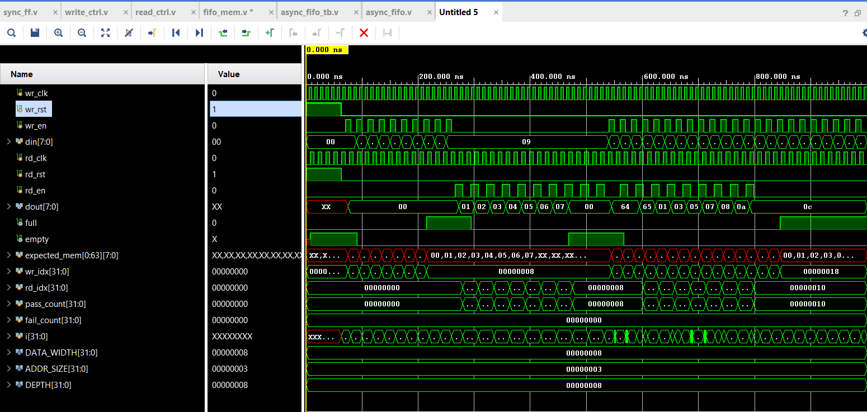

7. Synthesis Report — Register and LUT Utilization
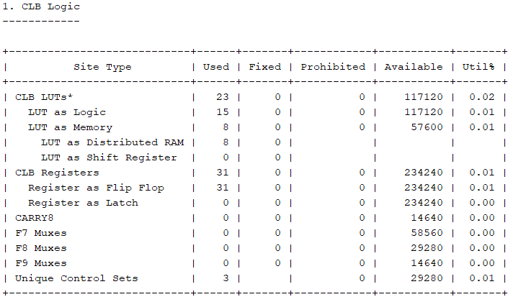

8. Constraints Used.
Constraint Type | Signal / Port | Value / Setting
NA | NA | NA

